Театральная постановка
«Том Сойер»
Scene 1
Narrator: In South America there is a small house. A boy named Tom Sawyer lives in it. Amazing adventures happen with him all the time.
Aunt Polly: Tom! Tom! Where is that boy? Where are you, Tom?
Tom: Here I am.
Aunt Polly: Oh, you’ve been in that closet. What were you doing there?
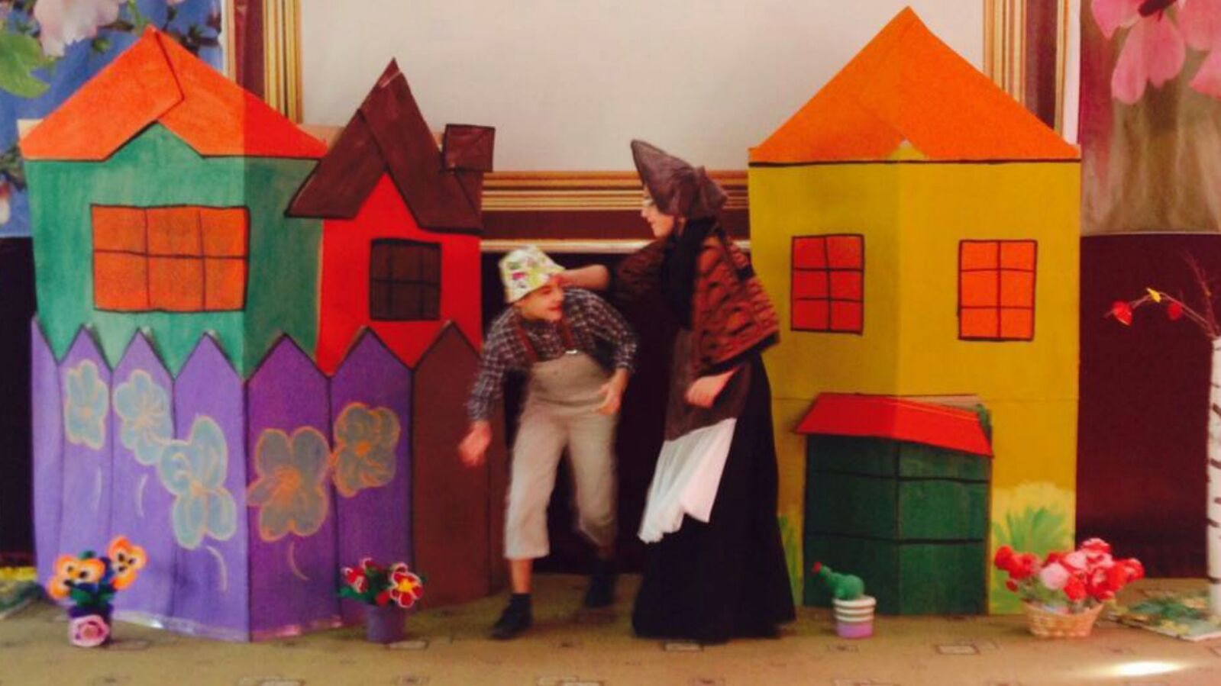
Tom: Nothing.
Aunt Polly: Nothing! Look at your hands. And look at your mouth. What is that?
Tom: I don’t know, Aunt.
Aunt Polly: Well, I know. It’s jam, that’s what it is.I have told you not to touch it! Hand me that switch!
Tom: Oh, look behind you, Aunt!
Aunt Polly: Where?
Aunt Polly: Well, again, ran away! And what's a boy!
Scene 2
Narrator: So, Tom escaped from Aunt Polly. On his way he met Huckleberry Finn. He was a little ragged fellow.
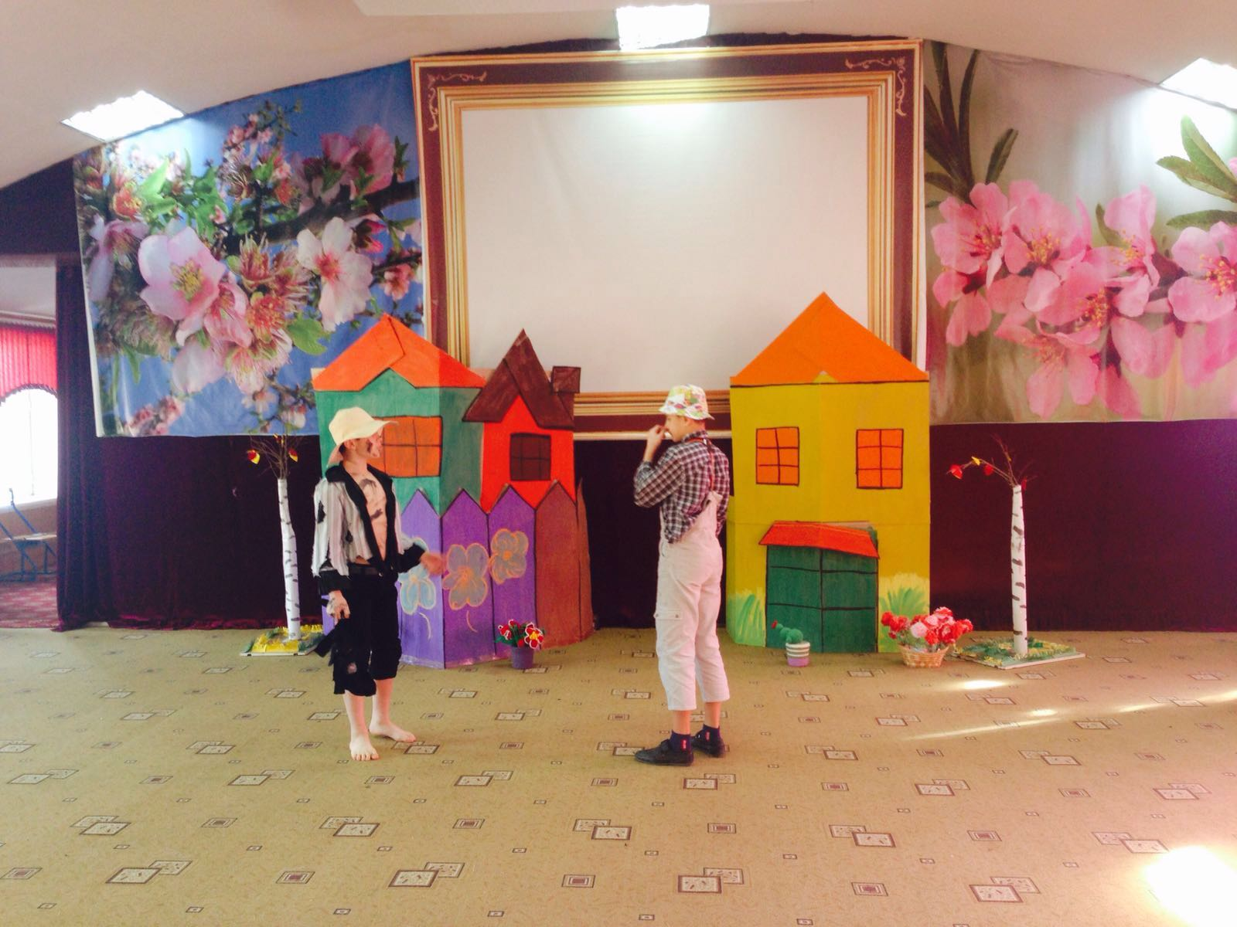
Tom: Hello, Huck!
Huck: And hello to you, if not kidding!
Tom: What’s that?
Huck: Dead Cat.
Tom: Let me see! And where have you taken it?
Huck: I’ve bought it.
Tom: Hey, Huck, and why do you need this dead cat?
Huck: Do not you know? To reduce warts!
Tom: How?
Huck: You take your cat and go to the cemetery at midnight, after some big sinner being buried there. Exactly at midnight, a devil will come for him. You must throw a cat after it.
Tom: And have you ever tried it yourself , Huck?
Huck: Never. But tonight I want to try. I think that the devil will come for Williams tonight , who had just been buried. They say he was a great sinner.
Tom: Hey, Huck, and take me too?
Huck: I'll take if you are not afraid.
Tom: Afraid ? Fuff!
Huck: Deal! Buy , Huck!
Scene 3
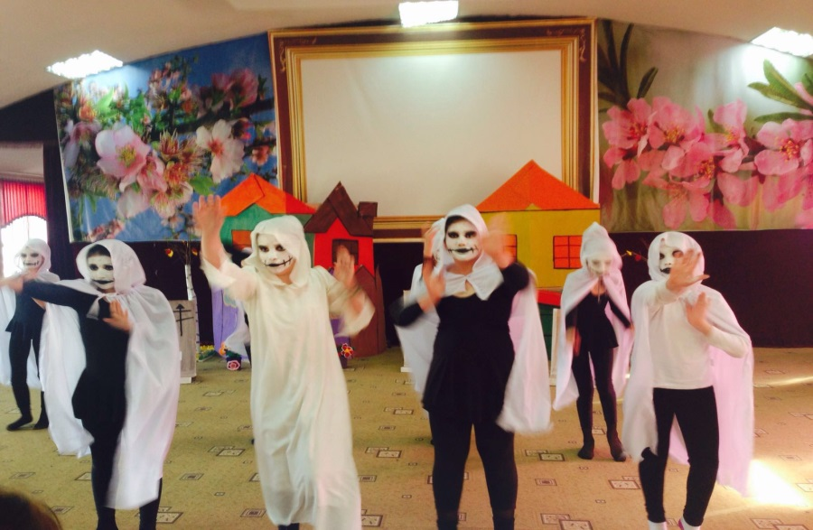
Tom: Hey, Huck, and Will the dead be offended because of our coming here?
Huck: Where do I know? It’s scary here, isn’t it?
Tom: of course it is! Hush! Look! What is it?
Huck: This is probably a hell fire! Oh, I’m afraid!
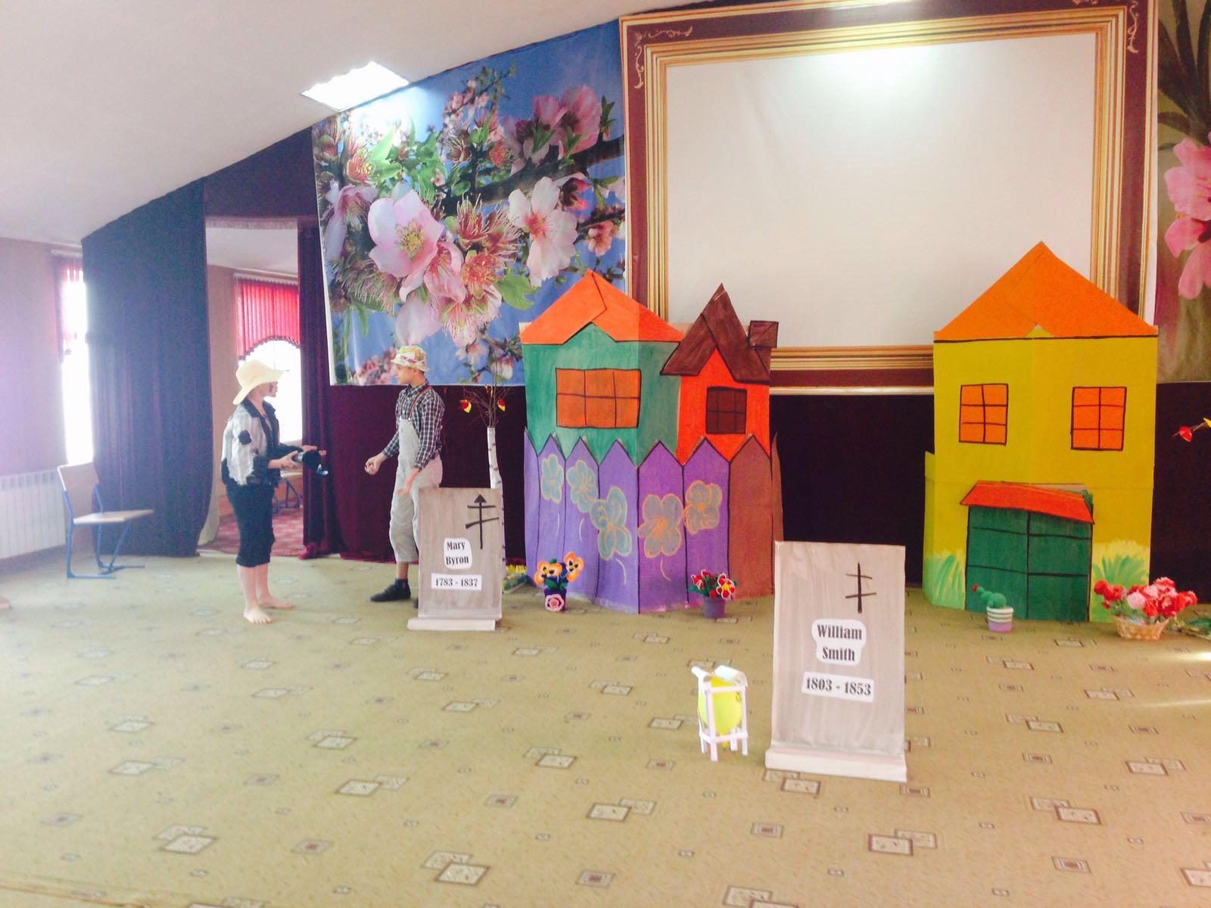
Dr. Robins: Here.
Injun Joe: Okay! Muff, give me your knife! It is necessary to prepare the rope!
Injun Joe: We will dig him now! Just give us five more pounds!
Dr. Robins: Look, what does this mean? I've already paid to you!
Injun Joe: But you still have a dept! Five years ago, you threw me out of your dad’s house, when I came to it! I sweared then to revenge! It's time to return the dept!
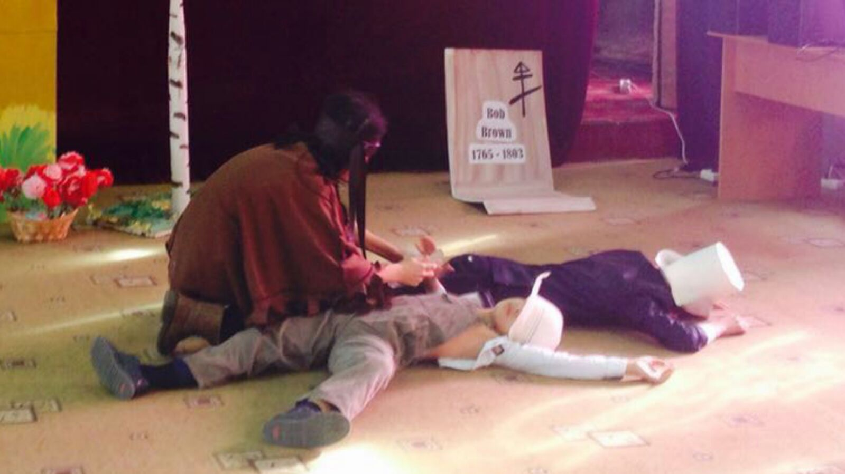
Muff Potter: What’s that?
Injun Joe: Yes, Muff, it’s not good ! Why did you do that?
Muff Potter: Me? No, it's not me!
Injun Joe: And who, Muff? Here's your knife!
Muff Potter: Oh, Joe! What have I done?
Tom: Heck, What do you think , how will it end?
Huck: I think If Dr. Robins dies, it will end with gallows-tree!
Tom: And who will tell? we?
Huck: What are you, Tom! If Injun Joe is not hung, he will kill us! You know what revengeful he is!
Tom: Huck, but won’t you let out?
Huck: What are you, Tom! I want to live! We mustn’t tell anyone!
Tom: Huck, let’s swear that we will not tell anyone!
Scene 4
Tom: Hey, Huck!
Huck: Hi, Tom!
Tom: Have you heard that there will be a trial tomorrow?
Huck: Yes , I have!
Tom: What shall we do, Huck? Mef Potter will be hanged, but he is not guilty!
Huck: Yes, Tom, I'm sorry for it! Though he is a drunkard, but he is! A good man!
Tom: Well , it would be good if we could help him!
Huck: But how?
Tom: Well, for example, we could help him to escape!
Scene 5
Narrator: That night Tom slept very badly: tossing and turning, waking up without end. And early in the morning he got up and went somewhere. At noon, the trial began.
Judge: So, we have questioned the main witness, Injun Joe, who told us in detail how it all happened. The prosecutor believes that the charge is proved. Lawyers have something else in favor of the defendant?
Lawyer: Yes, Your Honor! I beg to call Thomas Sawyer.
Referee: Call Thomas Sawyer!
(Enters Tom)
Attorney Thomas Sawyer, tell us where you were on the night of June 17, around midnight?
Tom: At the cemetery, sir!
Lawyer: You were hiding somewhere?
Tom: Yes, sir! Not far from the graves of Williams!
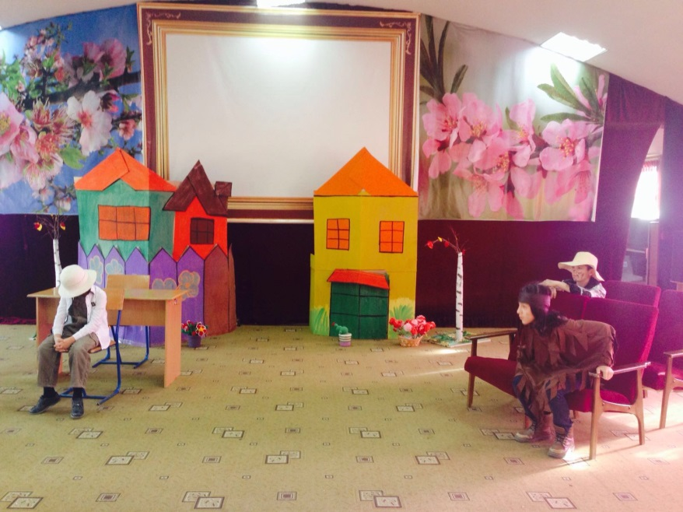
Lawyer: Okay! And now tell me what you saw.
Tom: We have seen the light of a lantern and vote. When people came closer, we heard Dr. Robins, Mef Potter and Injun Joe. Dr. Joe began to argue, and then they began to fight. Muff Potter joined them. And then the doctor hit Mefa Potter, and he fell, and Injun Joe grabbed Maf’s knife, swung at the doctor and ...
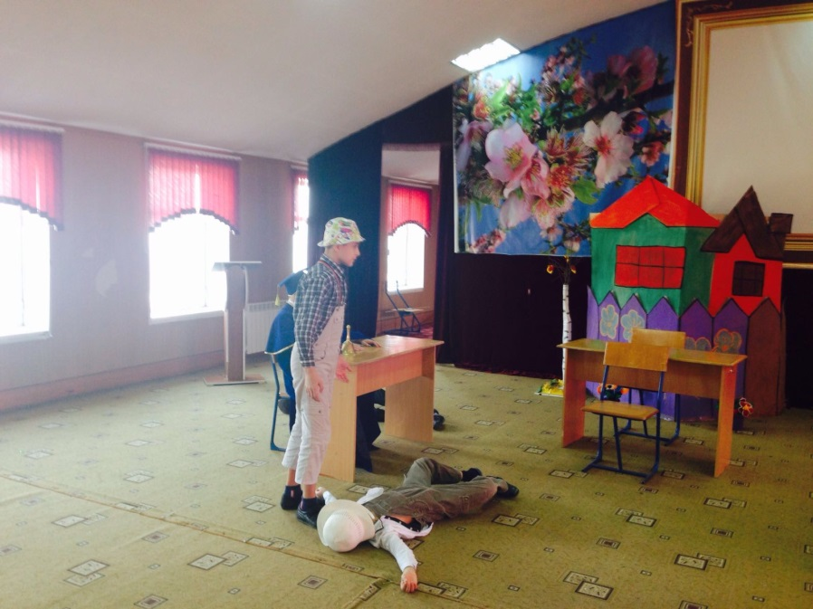
Scene 6
Narrator: A month has passed. Injun Joe did not manage to catch. Tom Sawyer took a brilliant position in the town hero.

МБОУ «Гимназия № 3» им. Рагимовой В.К.

Конкурс театральных постановок на английском языке
“Kaleidoscope”
«Том Сойер»
Подготовили:
учащиеся 7 класса
Учитель:
Султанова А.С.

Дербент, 2015-2016 уч.г.

